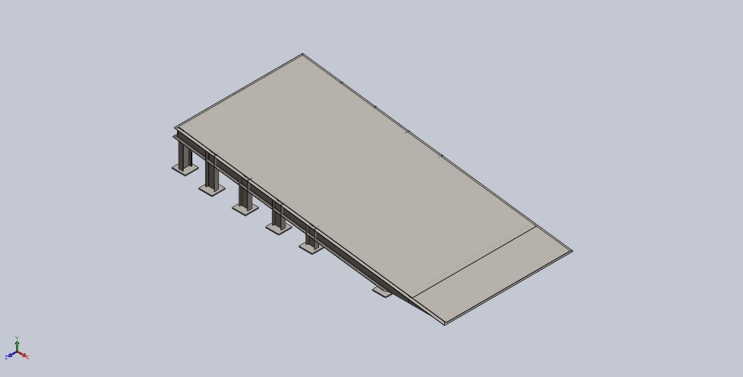
  Simulation of 1Assem1
  Date: 17 October 2025
  Designer: BHARATI SABALE
  Study name: Static 2
  Analysis type: Static
  Table of Contents
  Description 1
  Assumptions 2
  Model Information 3
  Study Properties 12
  Units 12
  Material Properties 13
  Loads and Fixtures 16
  Connector Definitions 16
  Interaction Information 17
  Mesh information 17
  Sensor Details 18
  Resultant Forces 18
  Beams 19
  Study Results 23
  Conclusion 25

Description
No Data

Assumptions

Model Information

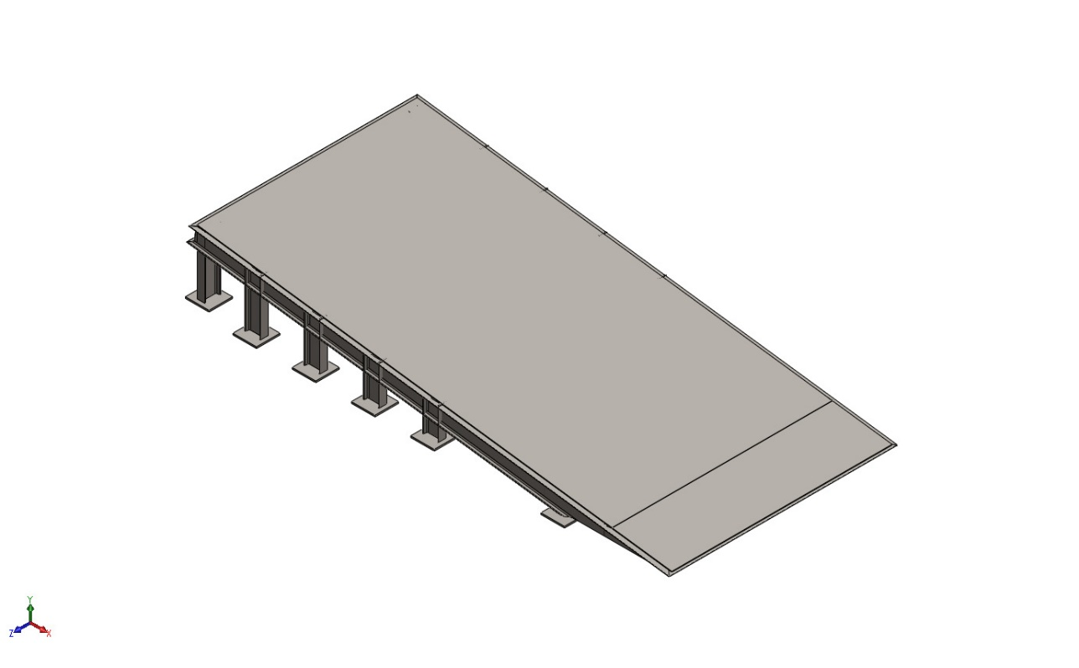
Model name: 1Assem1
Current Configuration: Default
Solid Bodies
Document Name and Reference | Treated As | Volumetric Properties | Document Path/Date Modified
Boss-Extrude1  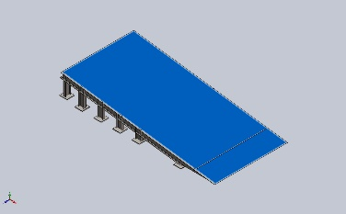 | Solid Body | Mass:167.323 kg  Volume:0.021315 m^3  Density:7,850 kg/m^3  Weight:1,639.76 N | C:\Users\Design\Desktop\dock ramp 1\1CHEQURED PLATE.SLDPRT  Oct 17 12:02:27 2025
Boss-Extrude1  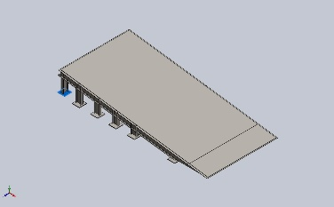 | Solid Body | Mass:1.76625 kg  Volume:0.000225 m^3  Density:7,850 kg/m^3  Weight:17.3093 N | C:\Users\Design\Desktop\dock ramp 1\1bottom plate.SLDPRT  Oct 17 04:49:50 2025
Boss-Extrude1  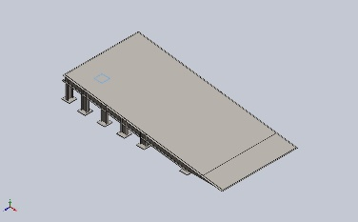 | Solid Body | Mass:1.76625 kg  Volume:0.000225 m^3  Density:7,850 kg/m^3  Weight:17.3093 N | C:\Users\Design\Desktop\dock ramp 1\1bottom plate.SLDPRT  Oct 17 04:49:50 2025
Boss-Extrude1  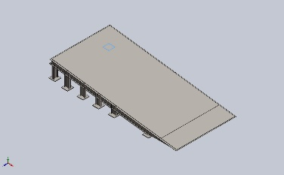 | Solid Body | Mass:1.76625 kg  Volume:0.000225 m^3  Density:7,850 kg/m^3  Weight:17.3093 N | C:\Users\Design\Desktop\dock ramp 1\1bottom plate.SLDPRT  Oct 17 04:49:50 2025
Boss-Extrude1  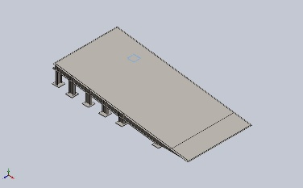 | Solid Body | Mass:1.76625 kg  Volume:0.000225 m^3  Density:7,850 kg/m^3  Weight:17.3093 N | C:\Users\Design\Desktop\dock ramp 1\1bottom plate.SLDPRT  Oct 17 04:49:50 2025
Boss-Extrude1  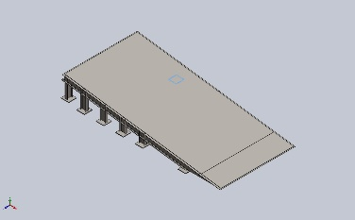 | Solid Body | Mass:1.76625 kg  Volume:0.000225 m^3  Density:7,850 kg/m^3  Weight:17.3093 N | C:\Users\Design\Desktop\dock ramp 1\1bottom plate.SLDPRT  Oct 17 04:49:50 2025
Boss-Extrude1  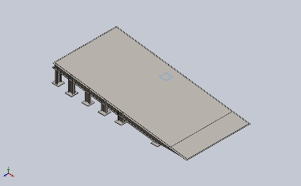 | Solid Body | Mass:1.76625 kg  Volume:0.000225 m^3  Density:7,850 kg/m^3  Weight:17.3093 N | C:\Users\Design\Desktop\dock ramp 1\1bottom plate.SLDPRT  Oct 17 04:49:50 2025
Boss-Extrude1  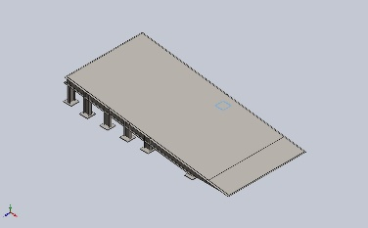 | Solid Body | Mass:1.76625 kg  Volume:0.000225 m^3  Density:7,850 kg/m^3  Weight:17.3093 N | C:\Users\Design\Desktop\dock ramp 1\1bottom plate.SLDPRT  Oct 17 04:49:50 2025
Boss-Extrude1  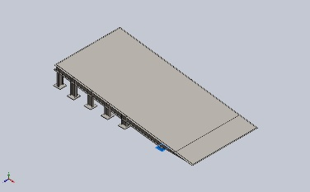 | Solid Body | Mass:1.76625 kg  Volume:0.000225 m^3  Density:7,850 kg/m^3  Weight:17.3093 N | C:\Users\Design\Desktop\dock ramp 1\1bottom plate.SLDPRT  Oct 17 04:49:50 2025
Boss-Extrude1  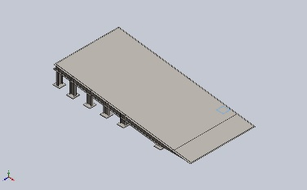 | Solid Body | Mass:1.76625 kg  Volume:0.000225 m^3  Density:7,850 kg/m^3  Weight:17.3093 N | C:\Users\Design\Desktop\dock ramp 1\1bottom plate.SLDPRT  Oct 17 04:49:50 2025
Boss-Extrude1  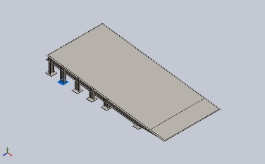 | Solid Body | Mass:1.76625 kg  Volume:0.000225 m^3  Density:7,850 kg/m^3  Weight:17.3093 N | C:\Users\Design\Desktop\dock ramp 1\1bottom plate.SLDPRT  Oct 17 04:49:50 2025
Boss-Extrude1  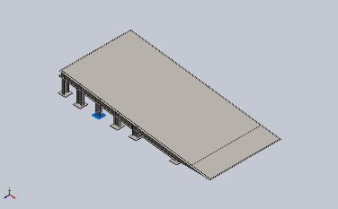 | Solid Body | Mass:1.76625 kg  Volume:0.000225 m^3  Density:7,850 kg/m^3  Weight:17.3093 N | C:\Users\Design\Desktop\dock ramp 1\1bottom plate.SLDPRT  Oct 17 04:49:50 2025
Boss-Extrude1  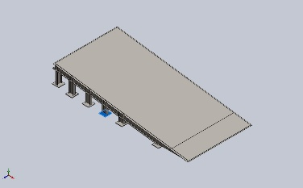 | Solid Body | Mass:1.76625 kg  Volume:0.000225 m^3  Density:7,850 kg/m^3  Weight:17.3093 N | C:\Users\Design\Desktop\dock ramp 1\1bottom plate.SLDPRT  Oct 17 04:49:50 2025
Boss-Extrude1  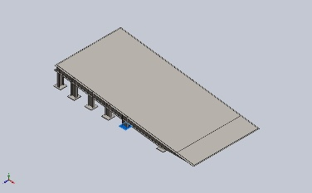 | Solid Body | Mass:1.76625 kg  Volume:0.000225 m^3  Density:7,850 kg/m^3  Weight:17.3092 N | C:\Users\Design\Desktop\dock ramp 1\1bottom plate.SLDPRT  Oct 17 04:49:50 2025
Beam Bodies:
Document Name and Reference | Formulation | Properties | Document Path/Date Modified
SolidBody 1(Sb beam 100 X 8(37)[3])  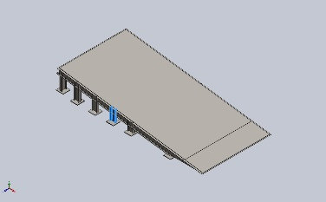 | Beam – Uniform C/S | Section Standard-weldment profiles/iso/sb beam  Section Area: 0.00109003m^2  Length:248.074mm  Volume:0.000270408m^3  Mass Density:7,850kg/m^3  Mass:2.1227kg  Weight:20.8025N | C:\Users\Design\Desktop\dock ramp 1\1sissior lift ramp.SLDPRT  Oct 17 19:22:04 2025
SolidBody 2(Sb beam 100 X 8(37)[8])  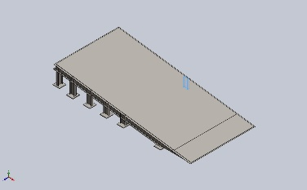 | Beam – Uniform C/S | Section Standard-weldment profiles/iso/sb beam  Section Area: 0.00109003m^2  Length:198.098mm  Volume:0.000215933m^3  Mass Density:7,850kg/m^3  Mass:1.69508kg  Weight:16.6117N | C:\Users\Design\Desktop\dock ramp 1\1sissior lift ramp.SLDPRT  Oct 17 19:22:04 2025
SolidBody 3(Trim/Extend7[3])  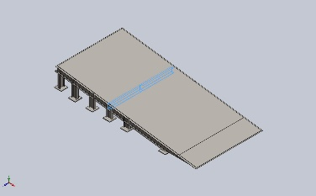 | Beam – Uniform C/S | Section Standard-weldment profiles/iso/c channel  Section Area: 0.00131018m^2  Length:1,373.39mm  Volume:0.00177894m^3  Mass Density:7,850kg/m^3  Mass:13.9646kg  Weight:136.853N | C:\Users\Design\Desktop\dock ramp 1\1sissior lift ramp.SLDPRT  Oct 17 19:22:04 2025
SolidBody 4(Trim/Extend2[2])  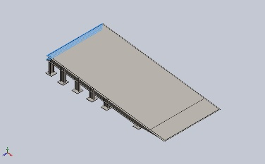 | Beam – Uniform C/S | Section Standard-  Section Area: 0.00109003m^2  Length:1,400mm  Volume:0.00152612m^3  Mass Density:7,850kg/m^3  Mass:11.9801kg  Weight:117.405N | C:\Users\Design\Desktop\dock ramp 1\1sissior lift ramp.SLDPRT  Oct 17 19:22:04 2025
SolidBody 5(Sb beam 100 X 8(12))  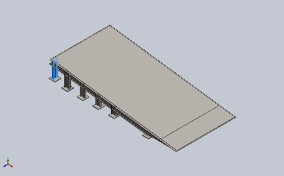 | Beam – Uniform C/S | Section Standard-weldment profiles/iso/sb beam  Section Area: 0.00109003m^2  Length:398mm  Volume:0.000433832m^3  Mass Density:7,850kg/m^3  Mass:3.40558kg  Weight:33.3747N | C:\Users\Design\Desktop\dock ramp 1\1sissior lift ramp.SLDPRT  Oct 17 19:22:04 2025
SolidBody 6(Sb beam 100 X 8(37)[6])  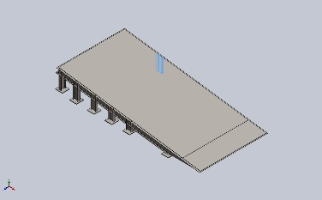 | Beam – Uniform C/S | Section Standard-weldment profiles/iso/sb beam  Section Area: 0.00109003m^2  Length:298.049mm  Volume:0.000324883m^3  Mass Density:7,850kg/m^3  Mass:2.55033kg  Weight:24.9932N | C:\Users\Design\Desktop\dock ramp 1\1sissior lift ramp.SLDPRT  Oct 17 19:22:04 2025
SolidBody 7(Sb beam 100 X 8(37)[1])  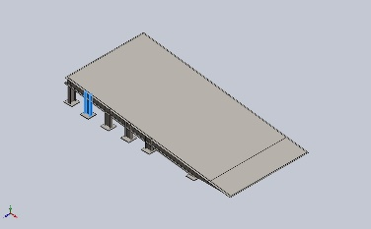 | Beam – Uniform C/S | Section Standard-weldment profiles/iso/sb beam  Section Area: 0.00109003m^2  Length:348.025mm  Volume:0.000379358m^3  Mass Density:7,850kg/m^3  Mass:2.97796kg  Weight:29.184N | C:\Users\Design\Desktop\dock ramp 1\1sissior lift ramp.SLDPRT  Oct 17 19:22:04 2025
SolidBody 8(Trim/Extend7[4])  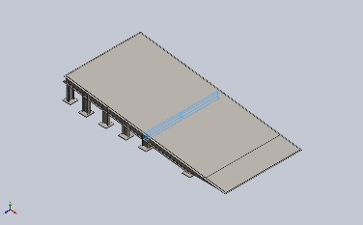 | Beam – Uniform C/S | Section Standard-weldment profiles/iso/c channel  Section Area: 0.00131018m^2  Length:1,373.39mm  Volume:0.00177894m^3  Mass Density:7,850kg/m^3  Mass:13.9646kg  Weight:136.853N | C:\Users\Design\Desktop\dock ramp 1\1sissior lift ramp.SLDPRT  Oct 17 19:22:04 2025
SolidBody 9(Sb beam 100 X 8(37)[4])  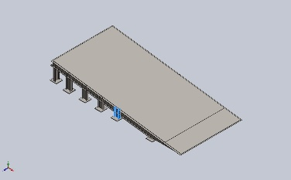 | Beam – Uniform C/S | Section Standard-weldment profiles/iso/sb beam  Section Area: 0.00109003m^2  Length:198.098mm  Volume:0.000215933m^3  Mass Density:7,850kg/m^3  Mass:1.69508kg  Weight:16.6117N | C:\Users\Design\Desktop\dock ramp 1\1sissior lift ramp.SLDPRT  Oct 17 19:22:04 2025
SolidBody 10(Sb beam 100 X 8(13))  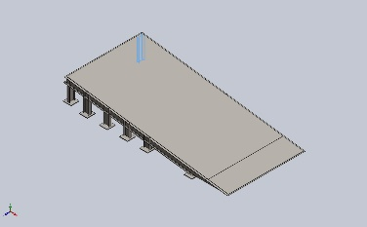 | Beam – Uniform C/S | Section Standard-weldment profiles/iso/sb beam  Section Area: 0.00109003m^2  Length:398mm  Volume:0.000433832m^3  Mass Density:7,850kg/m^3  Mass:3.40558kg  Weight:33.3747N | C:\Users\Design\Desktop\dock ramp 1\1sissior lift ramp.SLDPRT  Oct 17 19:22:04 2025
SolidBody 11(Trim/Extend7[1])  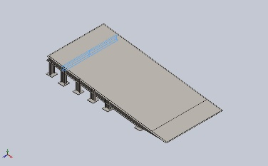 | Beam – Uniform C/S | Section Standard-weldment profiles/iso/c channel  Section Area: 0.00131018m^2  Length:1,373.39mm  Volume:0.00177894m^3  Mass Density:7,850kg/m^3  Mass:13.9646kg  Weight:136.853N | C:\Users\Design\Desktop\dock ramp 1\1sissior lift ramp.SLDPRT  Oct 17 19:22:04 2025
SolidBody 12(Sb beam 100 X 8(37)[7])  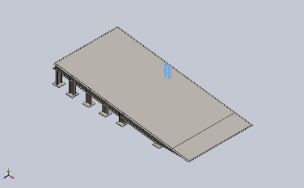 | Beam – Uniform C/S | Section Standard-weldment profiles/iso/sb beam  Section Area: 0.00109003m^2  Length:248.074mm  Volume:0.000270408m^3  Mass Density:7,850kg/m^3  Mass:2.1227kg  Weight:20.8025N | C:\Users\Design\Desktop\dock ramp 1\1sissior lift ramp.SLDPRT  Oct 17 19:22:04 2025
SolidBody 13(Trim/Extend7[5])  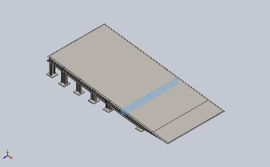 | Beam – Uniform C/S | Section Standard-weldment profiles/iso/c channel  Section Area: 0.00131018m^2  Length:1,373.39mm  Volume:0.00177894m^3  Mass Density:7,850kg/m^3  Mass:13.9646kg  Weight:136.853N | C:\Users\Design\Desktop\dock ramp 1\1sissior lift ramp.SLDPRT  Oct 17 19:22:04 2025
SolidBody 14(Sb beam 100 X 8(37)[2])  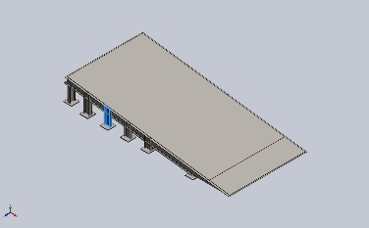 | Beam – Uniform C/S | Section Standard-weldment profiles/iso/sb beam  Section Area: 0.00109003m^2  Length:298.049mm  Volume:0.000324883m^3  Mass Density:7,850kg/m^3  Mass:2.55033kg  Weight:24.9932N | C:\Users\Design\Desktop\dock ramp 1\1sissior lift ramp.SLDPRT  Oct 17 19:22:04 2025
SolidBody 15(Sb beam 100 X 8(37)[5])  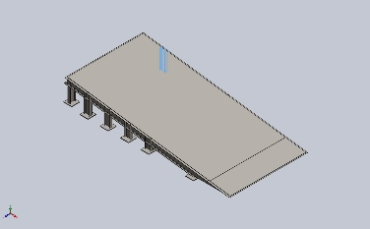 | Beam – Uniform C/S | Section Standard-weldment profiles/iso/sb beam  Section Area: 0.00109003m^2  Length:348.025mm  Volume:0.000379358m^3  Mass Density:7,850kg/m^3  Mass:2.97796kg  Weight:29.184N | C:\Users\Design\Desktop\dock ramp 1\1sissior lift ramp.SLDPRT  Oct 17 19:22:04 2025
SolidBody 16(Trim/Extend7[2])  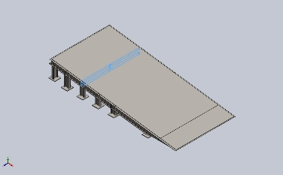 | Beam – Uniform C/S | Section Standard-weldment profiles/iso/c channel  Section Area: 0.00131018m^2  Length:1,373.39mm  Volume:0.00177894m^3  Mass Density:7,850kg/m^3  Mass:13.9646kg  Weight:136.853N | C:\Users\Design\Desktop\dock ramp 1\1sissior lift ramp.SLDPRT  Oct 17 19:22:04 2025
SolidBody 17(Sb beam 100 X 8(14))  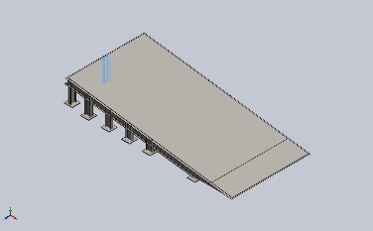 | Beam – Uniform C/S | Section Standard-weldment profiles/iso/sb beam  Section Area: 0.00109003m^2  Length:398mm  Volume:0.000433832m^3  Mass Density:7,850kg/m^3  Mass:3.40558kg  Weight:33.3747N | C:\Users\Design\Desktop\dock ramp 1\1sissior lift ramp.SLDPRT  Oct 17 19:22:04 2025
SolidBody 18(Trim/Extend7[6])  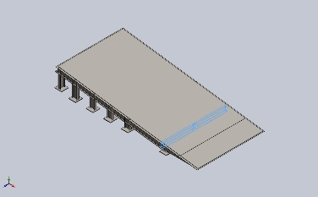 | Beam – Uniform C/S | Section Standard-weldment profiles/iso/c channel  Section Area: 0.00131018m^2  Length:1,373.39mm  Volume:0.00177894m^3  Mass Density:7,850kg/m^3  Mass:13.9646kg  Weight:136.853N | C:\Users\Design\Desktop\dock ramp 1\1sissior lift ramp.SLDPRT  Oct 17 19:22:04 2025
SolidBody 19(Trim/Extend6)  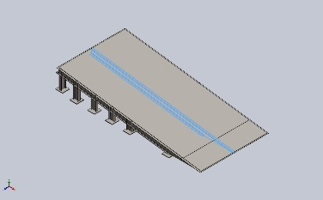 | Beam – Uniform C/S | Section Standard-  Section Area: 0.00109003m^2  Length:3,023.75mm  Volume:0.00295323m^3  Mass Density:7,850kg/m^3  Mass:23.1829kg  Weight:227.192N | C:\Users\Design\Desktop\dock ramp 1\1sissior lift ramp.SLDPRT  Oct 17 19:22:04 2025
SolidBody 20(Trim/Extend3[1])  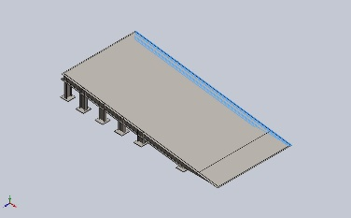 | Beam – Uniform C/S | Section Standard-weldment profiles/iso/sb beam  Section Area: 0.00109003m^2  Length:3,013.09mm  Volume:0.00295487m^3  Mass Density:7,850kg/m^3  Mass:23.1957kg  Weight:227.318N | C:\Users\Design\Desktop\dock ramp 1\1sissior lift ramp.SLDPRT  Oct 17 19:22:04 2025
SolidBody 21(Trim/Extend4[2])  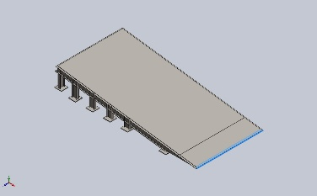 | Beam – Uniform C/S | Section Standard-  Section Area: 0.000360729m^2  Length:1,403.59mm  Volume:0.000506317m^3  Mass Density:7,850kg/m^3  Mass:3.97459kg  Weight:38.951N | C:\Users\Design\Desktop\dock ramp 1\1sissior lift ramp.SLDPRT  Oct 17 19:22:04 2025
SolidBody 22(C channel 100 X 10(1)[7])  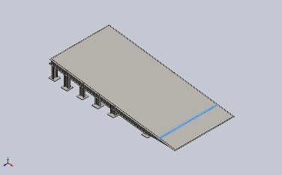 | Beam – Uniform C/S | Section Standard-weldment profiles/iso/c channel  Section Area: 0.000773088m^2  Length:1,400mm  Volume:0.00108232m^3  Mass Density:7,850kg/m^3  Mass:8.49624kg  Weight:83.2631N | C:\Users\Design\Desktop\dock ramp 1\1sissior lift ramp.SLDPRT  Oct 17 19:22:04 2025
SolidBody 23(Trim/Extend4[1])  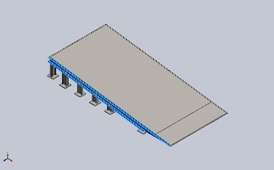 | Beam – Uniform C/S | Section Standard-weldment profiles/iso/sb beam  Section Area: 0.00109003m^2  Length:3,010.75mm  Volume:0.00295487m^3  Mass Density:7,850kg/m^3  Mass:23.1957kg  Weight:227.318N | C:\Users\Design\Desktop\dock ramp 1\1sissior lift ramp.SLDPRT  Oct 17 19:22:04 2025

Study Properties
Study name | Static 2
Analysis type | Static
Mesh type | Mixed Mesh
Thermal Effect: | On
Thermal option | Include temperature loads
Zero strain temperature | 298 Kelvin
Include fluid pressure effects from SOLIDWORKS Flow Simulation | Off
Solver type | Automatic
Inplane Effect: | Off
Soft Spring: | Off
Inertial Relief: | Off
Incompatible bonding options | Automatic
Large displacement | Off
Compute free body forces | On
Friction | Off
Use Adaptive Method: | Off
Result folder | SOLIDWORKS document (C:\Users\Design\Desktop\dock ramp 1)

Units
Unit system: | SI (MKS)
Length/Displacement | mm
Temperature | Kelvin
Angular velocity | Rad/sec
Pressure/Stress | N/m^2

Material Properties
Model Reference | Properties | Components
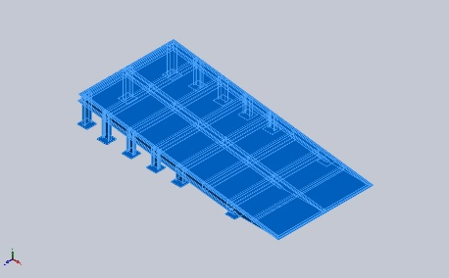 |  | SolidBody 1(Boss-Extrude1)(1CHEQURED PLATE-1),  SolidBody 1(Boss-Extrude1)(1bottom plate-1),  SolidBody 1(Boss-Extrude1)(1bottom plate-13),  SolidBody 1(Boss-Extrude1)(1bottom plate-15),  SolidBody 1(Boss-Extrude1)(1bottom plate-17),  SolidBody 1(Boss-Extrude1)(1bottom plate-19),  SolidBody 1(Boss-Extrude1)(1bottom plate-21),  SolidBody 1(Boss-Extrude1)(1bottom plate-23),  SolidBody 1(Boss-Extrude1)(1bottom plate-24),  SolidBody 1(Boss-Extrude1)(1bottom plate-25),  SolidBody 1(Boss-Extrude1)(1bottom plate-3),  SolidBody 1(Boss-Extrude1)(1bottom plate-5),  SolidBody 1(Boss-Extrude1)(1bottom plate-7),  SolidBody 1(Boss-Extrude1)(1bottom plate-9),  SolidBody 1(Sb beam 100 X 8(37)[3])(1sissior lift ramp-1),  SolidBody 2(Sb beam 100 X 8(37)[8])(1sissior lift ramp-1),  SolidBody 3(Trim/Extend7[3])(1sissior lift ramp-1),  SolidBody 4(Trim/Extend2[2])(1sissior lift ramp-1),  SolidBody 5(Sb beam 100 X 8(12))(1sissior lift ramp-1),  SolidBody 6(Sb beam 100 X 8(37)[6])(1sissior lift ramp-1),  SolidBody 7(Sb beam 100 X 8(37)[1])(1sissior lift ramp-1),  SolidBody 8(Trim/Extend7[4])(1sissior lift ramp-1),  SolidBody 9(Sb beam 100 X 8(37)[4])(1sissior lift ramp-1),  SolidBody 10(Sb beam 100 X 8(13))(1sissior lift ramp-1),  SolidBody 11(Trim/Extend7[1])(1sissior lift ramp-1),  SolidBody 12(Sb beam 100 X 8(37)[7])(1sissior lift ramp-1),  SolidBody 13(Trim/Extend7[5])(1sissior lift ramp-1),  SolidBody 14(Sb beam 100 X 8(37)[2])(1sissior lift ramp-1),  SolidBody 15(Sb beam 100 X 8(37)[5])(1sissior lift ramp-1),  SolidBody 16(Trim/Extend7[2])(1sissior lift ramp-1),  SolidBody 17(Sb beam 100 X 8(14))(1sissior lift ramp-1),  SolidBody 18(Trim/Extend7[6])(1sissior lift ramp-1),  SolidBody 19(Trim/Extend6)(1sissior lift ramp-1),  SolidBody 20(Trim/Extend3[1])(1sissior lift ramp-1),  SolidBody 21(Trim/Extend4[2])(1sissior lift ramp-1),  SolidBody 22(C channel 100 X 10(1)[7])(1sissior lift ramp-1),  SolidBody 23(Trim/Extend4[1])(1sissior lift ramp-1)
  Name: | AISI 4340 Steel, normalized
  Model type: | Linear Elastic Isotropic
  Default failure criterion: | Max von Mises Stress
  Yield strength: | 7.1e+08 N/m^2
  Tensile strength: | 1.11e+09 N/m^2
  Elastic modulus: | 2.05e+11 N/m^2
  Poisson's ratio: | 0.32
  Mass density: | 7,850 kg/m^3
  Shear modulus: | 8e+10 N/m^2
  Thermal expansion coefficient: | 1.23e-05 /Kelvin
Curve Data:N/A

Loads and Fixtures
Fixture name | Fixture Image | Fixture Details
Fixed-1 | 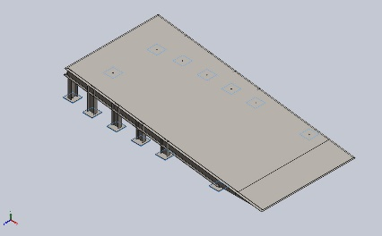
  Entities: | 13 face(s)
  Type: | Fixed Geometry
Resultant Forces
Components | X | Y | Z | Resultant
Reaction force(N) | 0 | 0 | 0 | 1e-33
Reaction Moment(N.m) | 0 | 0 | 0 | 1e-33

Load name | Load Image | Load Details
Force-1 | 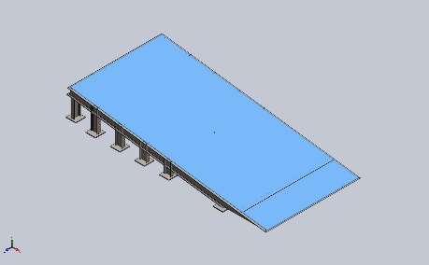
  Entities: | 1 face(s)
  Type: | Apply normal force
  Value: | 2,500 N

Connector Definitions
No Data

Interaction Information

Interaction | Interaction Image | Interaction Properties
Global Interaction | 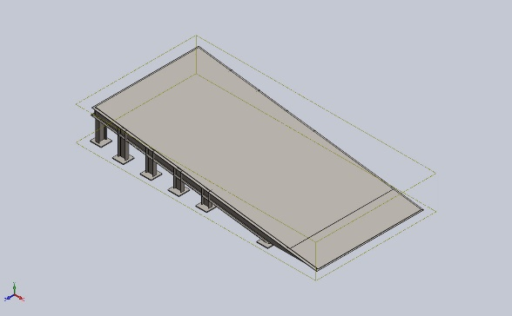
  Type: | Bonded
  Components: | 1 component(s)
  Options: | Independent mesh

Mesh information
Mesh type | Mixed Mesh
Mesher Used: | Blended curvature-based mesh
Jacobian points for High quality mesh | 16 Points
Jacobian check for shell | Off
Maximum element size | 60.7732 mm
Minimum element size | 60.7732 mm
Mesh Quality | High
Remesh failed parts independently | Off

Mesh information - Details
Total Nodes | 18973
Total Elements | 9239
Time to complete mesh(hh;mm;ss): | 00:00:11
Computer name:

Sensor Details
No Data

Resultant Forces

Reaction forces
Selection set | Units | Sum X | Sum Y | Sum Z | Resultant
Entire Model | N | 0 | 0 | 0 | 1e-33

Reaction Moments
Selection set | Units | Sum X | Sum Y | Sum Z | Resultant
Entire Model | N.m | 0 | 0 | 0 | 1e-33

Free body forces
Selection set | Units | Sum X | Sum Y | Sum Z | Resultant
Entire Model | N | -472.438 | 695.595 | 48.4164 | 842.255

Free body moments
Selection set | Units | Sum X | Sum Y | Sum Z | Resultant
Entire Model | N.m | 0 | 0 | 0 | 1e-33

Beams

Beam Forces
Beam Name | Joints | Axial(N) | Shear1(N) | Shear2(N) | Moment1(N.m) | Moment2(N.m) | Torque(N.m)
Beam-1(Sb beam 100 X 8(37)[3]) | 1 | 0 | 0 | 0 | 0 | 0 | 0
Beam-1(Sb beam 100 X 8(37)[3]) | 2 | 0 | 0 | 0 | 0 | 0 | 0
Beam-2(Sb beam 100 X 8(37)[8]) | 1 | 0 | 0 | 0 | 0 | 0 | 0
Beam-2(Sb beam 100 X 8(37)[8]) | 2 | 0 | 0 | 0 | 0 | 0 | 0
Beam-3(Trim/Extend7[3]) | 1 | 0 | 0 | 0 | 0 | 0 | 0
Beam-3(Trim/Extend7[3]) | 2 | 0 | 0 | 0 | 0 | 0 | 0
Beam-3(Trim/Extend7[3]) | 3 | 0 | 0 | 0 | 0 | 0 | 0
Beam-4(Trim/Extend2[2]) | 1 | 0 | 0 | 0 | 0 | 0 | 0
Beam-4(Trim/Extend2[2]) | 2 | 0 | 0 | 0 | 0 | 0 | 0
Beam-4(Trim/Extend2[2]) | 3 | 0 | 0 | 0 | 0 | 0 | 0
Beam-5(Sb beam 100 X 8(12)) | 1 | 0 | 0 | 0 | 0 | 0 | 0
Beam-5(Sb beam 100 X 8(12)) | 2 | 0 | 0 | 0 | 0 | 0 | 0
Beam-6(Sb beam 100 X 8(37)[6]) | 1 | 0 | 0 | 0 | 0 | 0 | 0
Beam-6(Sb beam 100 X 8(37)[6]) | 2 | 0 | 0 | 0 | 0 | 0 | 0
Beam-7(Sb beam 100 X 8(37)[1]) | 1 | 0 | 0 | 0 | 0 | 0 | 0
Beam-7(Sb beam 100 X 8(37)[1]) | 2 | 0 | 0 | 0 | 0 | 0 | 0
Beam-8(Trim/Extend7[4]) | 1 | 0 | 0 | 0 | 0 | 0 | 0
Beam-8(Trim/Extend7[4]) | 2 | 0 | 0 | 0 | 0 | 0 | 0
Beam-8(Trim/Extend7[4]) | 3 | 0 | 0 | 0 | 0 | 0 | 0
Beam-9(Sb beam 100 X 8(37)[4]) | 1 | 0 | 0 | 0 | 0 | 0 | 0
Beam-9(Sb beam 100 X 8(37)[4]) | 2 | 0 | 0 | 0 | 0 | 0 | 0
Beam-10(Sb beam 100 X 8(13)) | 1 | 0 | 0 | 0 | 0 | 0 | 0
Beam-10(Sb beam 100 X 8(13)) | 2 | 0 | 0 | 0 | 0 | 0 | 0
Beam-11(Trim/Extend7[1]) | 1 | 0 | 0 | 0 | 0 | 0 | 0
Beam-11(Trim/Extend7[1]) | 2 | 0 | 0 | 0 | 0 | 0 | 0
Beam-11(Trim/Extend7[1]) | 3 | 0 | 0 | 0 | 0 | 0 | 0
Beam-12(Sb beam 100 X 8(37)[7]) | 1 | 0 | 0 | 0 | 0 | 0 | 0
Beam-12(Sb beam 100 X 8(37)[7]) | 2 | 0 | 0 | 0 | 0 | 0 | 0
Beam-13(Trim/Extend7[5]) | 1 | 0 | 0 | 0 | 0 | 0 | 0
Beam-13(Trim/Extend7[5]) | 2 | 0 | 0 | 0 | 0 | 0 | 0
Beam-13(Trim/Extend7[5]) | 3 | 0 | 0 | 0 | 0 | 0 | 0
Beam-14(Sb beam 100 X 8(37)[2]) | 1 | 0 | 0 | 0 | 0 | 0 | 0
Beam-14(Sb beam 100 X 8(37)[2]) | 2 | 0 | 0 | 0 | 0 | 0 | 0
Beam-15(Sb beam 100 X 8(37)[5]) | 1 | 0 | 0 | 0 | 0 | 0 | 0
Beam-15(Sb beam 100 X 8(37)[5]) | 2 | 0 | 0 | 0 | 0 | 0 | 0
Beam-16(Trim/Extend7[2]) | 1 | 0 | 0 | 0 | 0 | 0 | 0
Beam-16(Trim/Extend7[2]) | 2 | 0 | 0 | 0 | 0 | 0 | 0
Beam-16(Trim/Extend7[2]) | 3 | 0 | 0 | 0 | 0 | 0 | 0
Beam-17(Sb beam 100 X 8(14)) | 1 | 0 | 0 | 0 | 0 | 0 | 0
Beam-17(Sb beam 100 X 8(14)) | 2 | 0 | 0 | 0 | 0 | 0 | 0
Beam-18(Trim/Extend7[6]) | 1 | 0 | 0 | 0 | 0 | 0 | 0
Beam-18(Trim/Extend7[6]) | 2 | 0 | 0 | 0 | 0 | 0 | 0
Beam-18(Trim/Extend7[6]) | 3 | 0 | 0 | 0 | 0 | 0 | 0
Beam-19(Trim/Extend6) | 1 | 0 | 0 | 0 | 0 | 0 | 0
Beam-19(Trim/Extend6) | 2 | 0 | 0 | 0 | 0 | 0 | 0
Beam-19(Trim/Extend6) | 3 | 0 | 0 | 0 | 0 | 0 | 0
Beam-19(Trim/Extend6) | 4 | 0 | 0 | 0 | 0 | 0 | 0
Beam-19(Trim/Extend6) | 5 | 0 | 0 | 0 | 0 | 0 | 0
Beam-19(Trim/Extend6) | 6 | 0 | 0 | 0 | 0 | 0 | 0
Beam-19(Trim/Extend6) | 7 | 0 | 0 | 0 | 0 | 0 | 0
Beam-19(Trim/Extend6) | 8 | 0 | 0 | 0 | 0 | 0 | 0
Beam-19(Trim/Extend6) | 9 | 0 | 0 | 0 | 0 | 0 | 0
Beam-20(Trim/Extend3[1]) | 1 | 0 | 0 | 0 | 0 | 0 | 0
Beam-20(Trim/Extend3[1]) | 2 | 0 | 0 | 0 | 0 | 0 | 0
Beam-20(Trim/Extend3[1]) | 3 | 0 | 0 | 0 | 0 | 0 | 0
Beam-20(Trim/Extend3[1]) | 4 | 0 | 0 | 0 | 0 | 0 | 0
Beam-20(Trim/Extend3[1]) | 5 | 0 | 0 | 0 | 0 | 0 | 0
Beam-20(Trim/Extend3[1]) | 6 | 0 | 0 | 0 | 0 | 0 | 0
Beam-20(Trim/Extend3[1]) | 7 | 0 | 0 | 0 | 0 | 0 | 0
Beam-20(Trim/Extend3[1]) | 8 | 0 | 0 | 0 | 0 | 0 | 0
Beam-20(Trim/Extend3[1]) | 9 | 0 | 0 | 0 | 0 | 0 | 0
Beam-21(Trim/Extend4[2]) | 1 | 0 | 0 | 0 | 0 | 0 | 0
Beam-21(Trim/Extend4[2]) | 2 | 0 | 0 | 0 | 0 | 0 | 0
Beam-21(Trim/Extend4[2]) | 3 | 0 | 0 | 0 | 0 | 0 | 0
Beam-22(C channel 100 X 10(1)[7]) | 1 | 0 | 0 | 0 | 0 | 0 | 0
Beam-22(C channel 100 X 10(1)[7]) | 2 | 0 | 0 | 0 | 0 | 0 | 0
Beam-22(C channel 100 X 10(1)[7]) | 3 | 0 | 0 | 0 | 0 | 0 | 0
Beam-23(Trim/Extend4[1]) | 1 | 0 | 0 | 0 | 0 | 0 | 0
Beam-23(Trim/Extend4[1]) | 2 | 0 | 0 | 0 | 0 | 0 | 0
Beam-23(Trim/Extend4[1]) | 3 | 0 | 0 | 0 | 0 | 0 | 0
Beam-23(Trim/Extend4[1]) | 4 | 0 | 0 | 0 | 0 | 0 | 0
Beam-23(Trim/Extend4[1]) | 5 | 0 | 0 | 0 | 0 | 0 | 0
Beam-23(Trim/Extend4[1]) | 6 | 0 | 0 | 0 | 0 | 0 | 0
Beam-23(Trim/Extend4[1]) | 7 | 0 | 0 | 0 | 0 | 0 | 0
Beam-23(Trim/Extend4[1]) | 8 | 0 | 0 | 0 | 0 | 0 | 0
Beam-23(Trim/Extend4[1]) | 9 | 0 | 0 | 0 | 0 | 0 | 0

Beam Stresses
Beam Name | Joints | Axial(N/m^2) | Bending Dir1(N/m^2) | Bending Dir2(N/m^2) | Torsional (N/m^2) | Upper bound axial and bending(N/m^2)
Beam-1(Sb beam 100 X 8(37)[3]) | 1 | 0 | 0 | 0 | 0 | 0
Beam-1(Sb beam 100 X 8(37)[3]) | 2 | 0 | 0 | 0 | 0 | 0
Beam-2(Sb beam 100 X 8(37)[8]) | 1 | 0 | 0 | 0 | 0 | 0
Beam-2(Sb beam 100 X 8(37)[8]) | 2 | 0 | 0 | 0 | 0 | 0
Beam-3(Trim/Extend7[3]) | 1 | 0 | 0 | 0 | 0 | 0
Beam-3(Trim/Extend7[3]) | 2 | 0 | 0 | 0 | 0 | 0
Beam-3(Trim/Extend7[3]) | 3 | 0 | 0 | 0 | 0 | 0
Beam-4(Trim/Extend2[2]) | 1 | 0 | 0 | 0 | 0 | 0
Beam-4(Trim/Extend2[2]) | 2 | 0 | 0 | 0 | 0 | 0
Beam-4(Trim/Extend2[2]) | 3 | 0 | 0 | 0 | 0 | 0
Beam-5(Sb beam 100 X 8(12)) | 1 | 0 | 0 | 0 | 0 | 0
Beam-5(Sb beam 100 X 8(12)) | 2 | 0 | 0 | 0 | 0 | 0
Beam-6(Sb beam 100 X 8(37)[6]) | 1 | 0 | 0 | 0 | 0 | 0
Beam-6(Sb beam 100 X 8(37)[6]) | 2 | 0 | 0 | 0 | 0 | 0
Beam-7(Sb beam 100 X 8(37)[1]) | 1 | 0 | 0 | 0 | 0 | 0
Beam-7(Sb beam 100 X 8(37)[1]) | 2 | 0 | 0 | 0 | 0 | 0
Beam-8(Trim/Extend7[4]) | 1 | 0 | 0 | 0 | 0 | 0
Beam-8(Trim/Extend7[4]) | 2 | 0 | 0 | 0 | 0 | 0
Beam-8(Trim/Extend7[4]) | 3 | 0 | 0 | 0 | 0 | 0
Beam-9(Sb beam 100 X 8(37)[4]) | 1 | 0 | 0 | 0 | 0 | 0
Beam-9(Sb beam 100 X 8(37)[4]) | 2 | 0 | 0 | 0 | 0 | 0
Beam-10(Sb beam 100 X 8(13)) | 1 | 0 | 0 | 0 | 0 | 0
Beam-10(Sb beam 100 X 8(13)) | 2 | 0 | 0 | 0 | 0 | 0
Beam-11(Trim/Extend7[1]) | 1 | 0 | 0 | 0 | 0 | 0
Beam-11(Trim/Extend7[1]) | 2 | 0 | 0 | 0 | 0 | 0
Beam-11(Trim/Extend7[1]) | 3 | 0 | 0 | 0 | 0 | 0
Beam-12(Sb beam 100 X 8(37)[7]) | 1 | 0 | 0 | 0 | 0 | 0
Beam-12(Sb beam 100 X 8(37)[7]) | 2 | 0 | 0 | 0 | 0 | 0
Beam-13(Trim/Extend7[5]) | 1 | 0 | 0 | 0 | 0 | 0
Beam-13(Trim/Extend7[5]) | 2 | 0 | 0 | 0 | 0 | 0
Beam-13(Trim/Extend7[5]) | 3 | 0 | 0 | 0 | 0 | 0
Beam-14(Sb beam 100 X 8(37)[2]) | 1 | 0 | 0 | 0 | 0 | 0
Beam-14(Sb beam 100 X 8(37)[2]) | 2 | 0 | 0 | 0 | 0 | 0
Beam-15(Sb beam 100 X 8(37)[5]) | 1 | 0 | 0 | 0 | 0 | 0
Beam-15(Sb beam 100 X 8(37)[5]) | 2 | 0 | 0 | 0 | 0 | 0
Beam-16(Trim/Extend7[2]) | 1 | 0 | 0 | 0 | 0 | 0
Beam-16(Trim/Extend7[2]) | 2 | 0 | 0 | 0 | 0 | 0
Beam-16(Trim/Extend7[2]) | 3 | 0 | 0 | 0 | 0 | 0
Beam-17(Sb beam 100 X 8(14)) | 1 | 0 | 0 | 0 | 0 | 0
Beam-17(Sb beam 100 X 8(14)) | 2 | 0 | 0 | 0 | 0 | 0
Beam-18(Trim/Extend7[6]) | 1 | 0 | 0 | 0 | 0 | 0
Beam-18(Trim/Extend7[6]) | 2 | 0 | 0 | 0 | 0 | 0
Beam-18(Trim/Extend7[6]) | 3 | 0 | 0 | 0 | 0 | 0
Beam-19(Trim/Extend6) | 1 | 0 | 0 | 0 | 0 | 0
Beam-19(Trim/Extend6) | 2 | 0 | 0 | 0 | 0 | 0
Beam-19(Trim/Extend6) | 3 | 0 | 0 | 0 | 0 | 0
Beam-19(Trim/Extend6) | 4 | 0 | 0 | 0 | 0 | 0
Beam-19(Trim/Extend6) | 5 | 0 | 0 | 0 | 0 | 0
Beam-19(Trim/Extend6) | 6 | 0 | 0 | 0 | 0 | 0
Beam-19(Trim/Extend6) | 7 | 0 | 0 | 0 | 0 | 0
Beam-19(Trim/Extend6) | 8 | 0 | 0 | 0 | 0 | 0
Beam-19(Trim/Extend6) | 9 | 0 | 0 | 0 | 0 | 0
Beam-20(Trim/Extend3[1]) | 1 | 0 | 0 | 0 | 0 | 0
Beam-20(Trim/Extend3[1]) | 2 | 0 | 0 | 0 | 0 | 0
Beam-20(Trim/Extend3[1]) | 3 | 0 | 0 | 0 | 0 | 0
Beam-20(Trim/Extend3[1]) | 4 | 0 | 0 | 0 | 0 | 0
Beam-20(Trim/Extend3[1]) | 5 | 0 | 0 | 0 | 0 | 0
Beam-20(Trim/Extend3[1]) | 6 | 0 | 0 | 0 | 0 | 0
Beam-20(Trim/Extend3[1]) | 7 | 0 | 0 | 0 | 0 | 0
Beam-20(Trim/Extend3[1]) | 8 | 0 | 0 | 0 | 0 | 0
Beam-20(Trim/Extend3[1]) | 9 | 0 | 0 | 0 | 0 | 0
Beam-21(Trim/Extend4[2]) | 1 | 0 | 0 | 0 | 0 | 0
Beam-21(Trim/Extend4[2]) | 2 | 0 | 0 | 0 | 0 | 0
Beam-21(Trim/Extend4[2]) | 3 | 0 | 0 | 0 | 0 | 0
Beam-22(C channel 100 X 10(1)[7]) | 1 | 0 | 0 | 0 | 0 | 0
Beam-22(C channel 100 X 10(1)[7]) | 2 | 0 | 0 | 0 | 0 | 0
Beam-22(C channel 100 X 10(1)[7]) | 3 | 0 | 0 | 0 | 0 | 0
Beam-23(Trim/Extend4[1]) | 1 | 0 | 0 | 0 | 0 | 0
Beam-23(Trim/Extend4[1]) | 2 | 0 | 0 | 0 | 0 | 0
Beam-23(Trim/Extend4[1]) | 3 | 0 | 0 | 0 | 0 | 0
Beam-23(Trim/Extend4[1]) | 4 | 0 | 0 | 0 | 0 | 0
Beam-23(Trim/Extend4[1]) | 5 | 0 | 0 | 0 | 0 | 0
Beam-23(Trim/Extend4[1]) | 6 | 0 | 0 | 0 | 0 | 0
Beam-23(Trim/Extend4[1]) | 7 | 0 | 0 | 0 | 0 | 0
Beam-23(Trim/Extend4[1]) | 8 | 0 | 0 | 0 | 0 | 0
Beam-23(Trim/Extend4[1]) | 9 | 0 | 0 | 0 | 0 | 0

Study Results

Name | Type | Min | Max
Stress1 | VON: von Mises Stress | 0.000e+00N/m^2  Node: 16196 | 1.186e+08N/m^2  Node: 8124
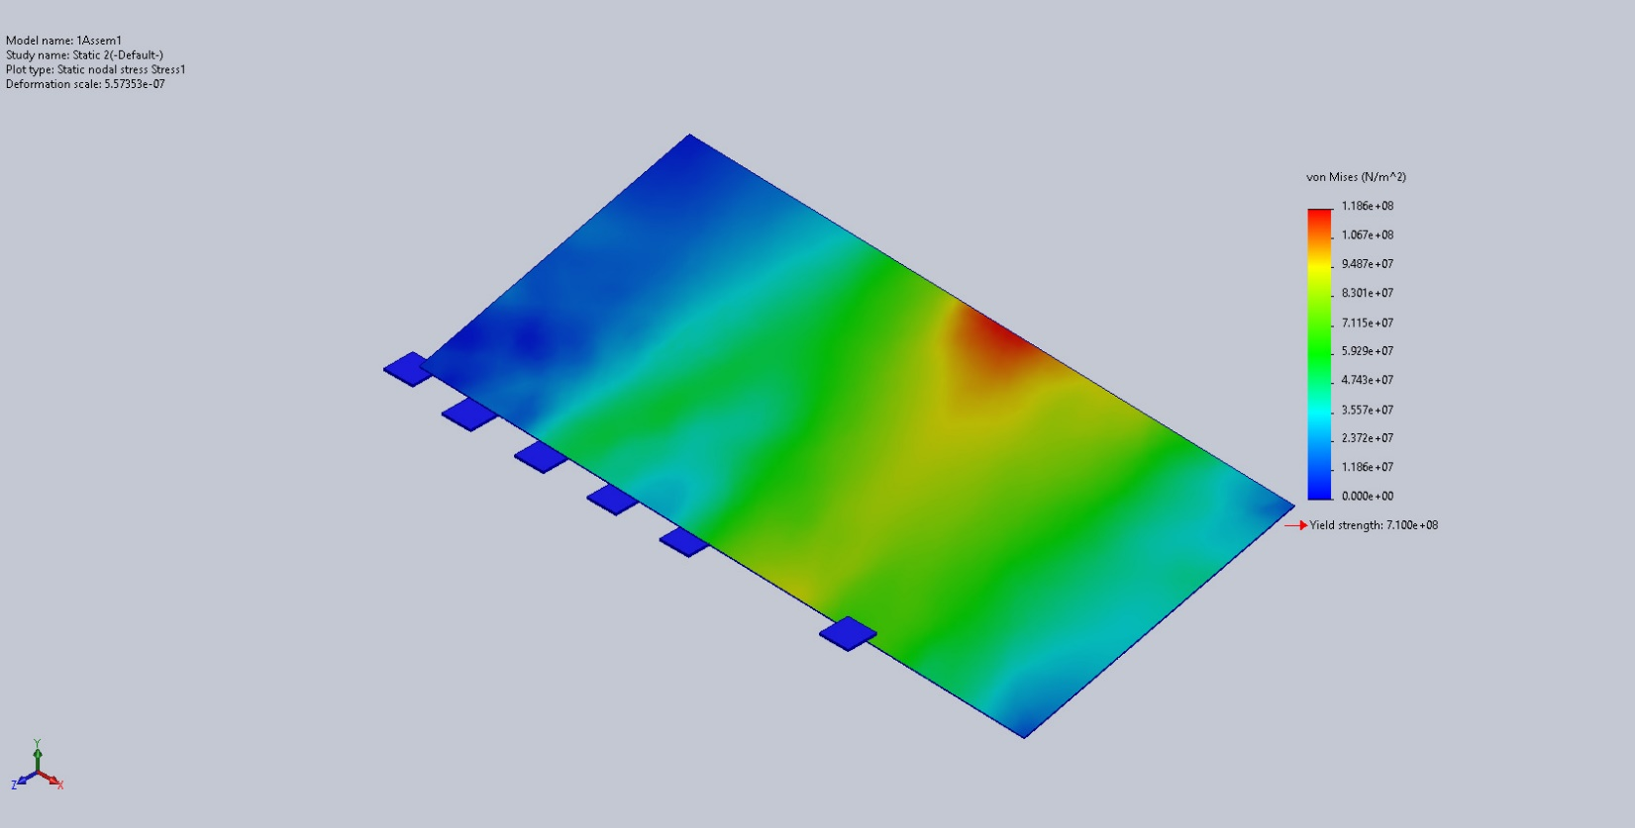
1Assem1-Static 2-Stress-Stress1

Name | Type | Min | Max
Displacement1 | URES: Resultant Displacement | 0.000e+00mm  Node: 16196 | 6.095e+08mm  Node: 8
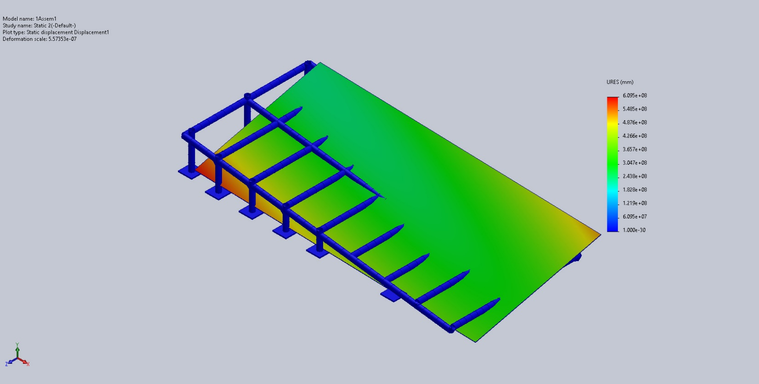
1Assem1-Static 2-Displacement-Displacement1

Name | Type | Min | Max
Strain1 | ESTRN: Equivalent Strain | 0.000e+00  Element: 7913 | 2.799e-04  Element: 467
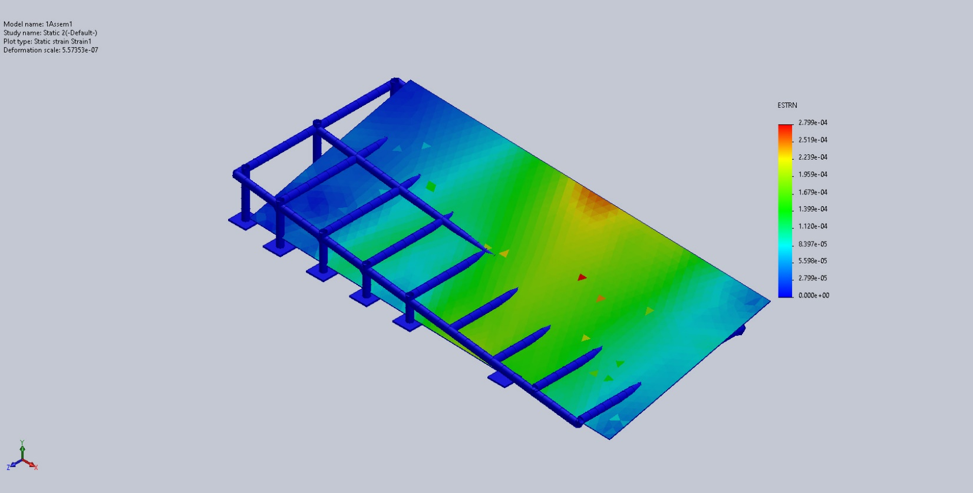
1Assem1-Static 2-Strain-Strain1

Conclusion

